Colors and Polarization

Experiment
8

Purposes:
- To emphasize the relationship between light wavelength and color, by studying the process of color addition (principle of color TV), and color subtraction (principle of color printing).

- To consider the operation of color filters as systems whose electrons are vibrated strongly by some wavelengths (those absorbed or scattered) and weakly by other wavelengths (those transmitted). To relate the operation of these filters to various natural phenomena: blue sky/red sunset (sky filters out, or "scatters", blue light), "greenhouse effect" (C0₂ filters out IR), ozone layer (ozone filters out UV), green plants (leaves filter out red light, and some blue), blue ocean (water filters out red light).

Equipment Needed:

- Ray box with three Additive primary color filters;
- Overhead projector with three Subtractive primary color filters;
- Printed color pictures

Theory / Procedure / Data:

- COLOR ADDITION:
Our brain can distinguish the different wavelengths of light through the sensation of color. Red light has a long wavelength, green has a shorter wavelength, and blue the shortest wavelength of the visible waves. Your eye can be fooled into thinking it sees a color which is not really there! That's how your color TV works--- all the apparently different colors you see on the TV are formed with only three wavelengths of light... the THREE ADDITIVE PRIMARY COLORS, red, green and blue.

Use RAY BOX to view the following combinations, and insert the correct answer from these choices... cyan, magenta, yellow and white.

Blue plus green, the color you see where they overlap ________;
Blue plus red, the color you see where they overlap _______;
Red plus green, the color you see where they overlap _______;
Red plus green plus blue, the color you see where they overlap _______.

- COLOR SUBTRACTION:
Color photographs and printed pictures use three SUBTRACTIVE PRIMARY COLORS (yellow, cyan, and magenta)
As we saw above, yellow is ___________ plus ___________; cyan is ___________ plus ___________; and magenta is ___________ plus___________. Therefore, each SUBTRACTIVE primary filter lets 2 PRIMARY colors through.

Use the OVERHEAD PROJECTOR to view the effect of laying one filter over another, and fill in the answers from the choices… blue, red, green. Note that in each case the color you see is the only one that BOTH filters transmit!

Magenta on cyan, write down the color common to both that you see _______;
Magenta on yellow, write down the color common to both that you see _______;
Yellow on cyan, write down the color common to both that you see _______;
Yellow on cyan on magenta, write down the color common to all that you see _______.

Now, view these pictures: elephant on dog, and pig on moth. For each picture, use the color circles below and fill in the blanks to explain the color seen on each animal... (fill in blanks with red, blue, or green)

Cyan elephant (green plus ___________ get through)
Color of fish is ___________
Yellow dog (green plus ___________ get through)

Yellow moth (red plus ___________ get through)
Color of snail is ___________
Magenta pig (red plus ___________ get through)

Part II: Polarization

Purpose:
To determine the relationship between the intensity of the transmitted light through two polarizers with the angle, φ of the axes of the two polarizers.

Equipment needed:

- Two polarizers,
- Light sources (laser and light box),
- Low Sensitivity Light sensor and Rotary motion sensor

Background:

A polarizer only allows light that is vibrating in a particular plane to pass through it. This plane forms the “axis” of polarization. Unpolarized light vibrates in all planes perpendicular to the direction of propagation. If unpolarized light is incident upon an “ideal” polarizer, only half will be transmitted through the polarizer. Since, in reality, no polarizer is “ideal”, less than half the light will be transmitted.
The transmitted light is polarized in one plane. If this polarized light is incident upon a second polarizer, the axis of which is oriented such that it is perpendicular to the plane of polarization of the incident light, no light will be transmitted through the second polarizer (see the top figure). | 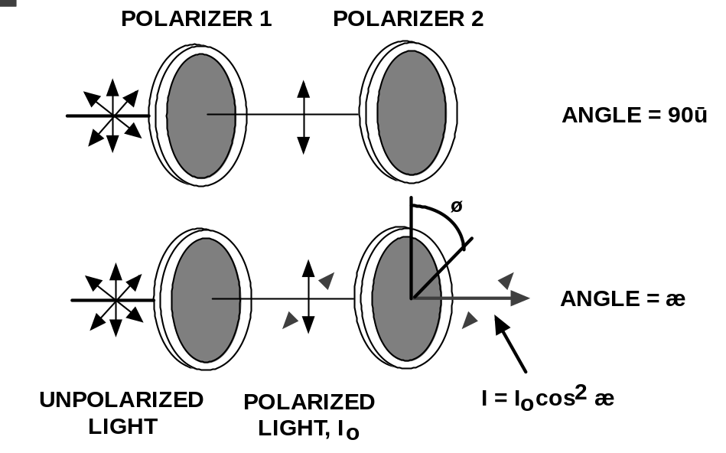
However, if the second polarizer is oriented at an angle so that it is not perpendicular to the first polarizer, there will be some component of the electric field of the polarized light that lies in the same direction as the axis of the second polarizer, thus some light will be transmitted through the second polarizer (see the bottom figure).

The component, E, of the polarized electric field, E_{O}, is found by:

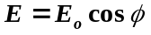
Since the intensity of the light varies as the square of the electric field, the light intensity transmitted through the second filter is given by:

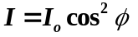

where I_{O} is the intensity of the light passing through the first filter and φ is the angle between the polarization axes of the two filters.

Consider the two extreme cases illustrated by this equation:

- If φ is zero, the second polarizer is aligned with the first polarizer, and the value of cos²φ is one. Thus the intensity transmitted by the second filter is equal to the light intensity that passes through the first filter. This case will allow maximum intensity to pass through.
- If φ is 90˚, the second polarizer is oriented perpendicular to the plane of polarization of the first filter, and the cos²(90⁰) gives zero. Thus no light is transmitted through the second filter. This case will allow minimum intensity to pass through.
- These results assume that the only absorption of light is due to polarizer effects. In fact most polarizing films are not clear and thus there is also some absorption of light due to the coloring of the Polaroid filters.

For You to Do:

Use the Light Sensor to measure the relative intensity of light that passes through two polarizers. Change the angle of the second polarizer relative to the first polarizer. Use the Rotary Motion Sensor to measure the angle of the second polarizer relative to the first polarizer.

Use DataStudio to record and display the light intensity and the angle between the axes of the polarizers. Use the program’s built-in calculator to compare the relative intensity to the angle and the cosine² of the angle.
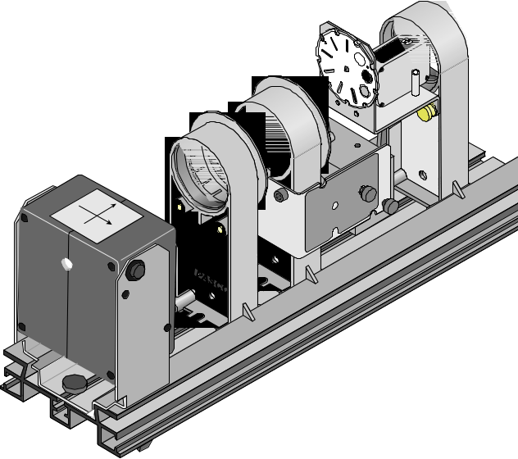
Procedure:

- Set your equipment as shown above, and launch a file named “Polarization.ds”.

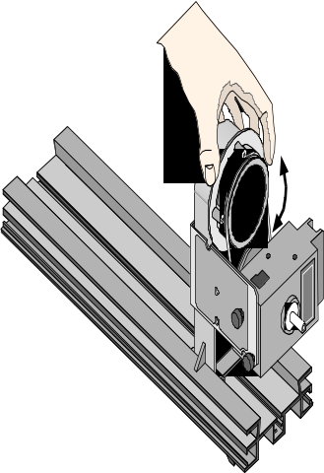
- Turn on the light source (laser), set the opening to the light sensor to slit 1, and adjust the two polarizers for maximum transmission of light, thus φ = 0. (e.g. turn both polarizers’ zero degree mark to the reference peg on the holder). If you are not careful with this step you will have difficulty interpreting the results. Make sure the measured intensity has the same value at two angles that are 180 degrees apart. If not, check your alignment.

- Click the ‘Start’ button in DataStudio and turn the second polarizer slowly and smoothly. Watch the results in the Graph display.

- Continue to turn the polarizer for at least one full rotation (360 degrees), and then stop recording data.

- If your displayed graph was saturated at the top (or bottom), change the Gain on the light sensor, until the graph shows a smooth function (with the angle, φ).

- Turn off the light source, and examine the Graph display for “Light Intensity versus Angular Position”. A fitting equation has already been defined for you in DataStudio. Copy and paste your graph in the “Data and Results” section.

- Next, examine the Graph display for “Light Intensity versus cosine² (angle)”. If the alignment of your system is perfect, your data will fall on a straight line; otherwise, the graph will be elliptical. This graph will indicate your ability to align the system.

- Replace the laser with the light box and repeat steps 2-7. For best results use slit 6 in front of the light sensor.

- Collect a similar set of data (repeat steps 2-7) for the microwave optics setup shown below. The electric field (λ=2.85cm, f=10.525GHz) produced by the microwave transmitter is polarized along the axis of the transmitter diode that produces the waves. The microwave receiver responds only to the component of a microwave signal that is along the diode axis. As a result, the transmitter and receiver must be initially setup to zero degrees (the horns of the transmitter and receiver must be oriented with the longer side horizontal). The receiver should be set to the 10x scale. The separation of the receiver and transmitter should produce a full scale deflection on the receiver. You need to decide how many data points to collect.

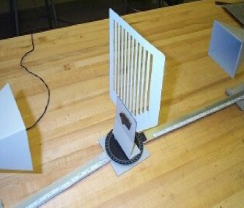
Note that the polarizer has long bars along which current can travel under the influence of an electric field, if E is along the direction of the bars. If E is in this direction then the polarizer will absorb its energy. Conversely, E is not absorbed when it is perpendicular to the bars. There is no unbroken path for current to traverse –current can't "jump" across the slits of the polarizer. This is counterintuitive to the situation where a string wave is wiggled through the slit of a polarizer, unless you bear in mind the underlying physical processes.

Data and Results:
Paste graphs here. You should have a total of six graphs for this report.
Questions:

- What is the shape of the graphs of the Light Intensity versus the Angular Position? Discuss the physical meaning of the curve fitting parameters.

- What is the shape of the graph of the Light Intensity versus the square of the cosine of the angle? Discuss the physical meaning of the curve fitting parameters.

- Compare the data for the laser and the light box. Is there anything peculiar about it? Explain?

