Experiment
8

Lenses, Mirrors, and Ray Tracing

Introduction
This experiment is designed to give you more experience with lenses and mirrors. Specifically, you will:
- Learn how to measure the focal length of lenses and mirrors using two techniques.
- Study the relationship between the object distance p and the image distance q for lenses and mirrors.
- Predict, using ray diagrams, the location of real images, virtual images, and virtual objects produced by lenses and mirrors.

Procedure
Part 1: Focal Length Measurements

Distant Object Method
- Place a converging lens in a lens holder on the optical bench and place the screen in its holder at the end of the optical bench. Place the object light source (lighted arrow) across the lab table on a second optical bench and align the two benches by sight (if you can find the image of a more distant object, do so). Be sure that the lens is between the object and the screen. Move the screen until a sharp real image of this distant object is formed on the screen. Repeat the procedure for the other converging lens and the concave mirror (in this case the screen will be between the object and the mirror). Since the object distance is very large, record the measured image distances in Table 1 as the focal length of the two converging lenses and the mirror. The converging lens with the longest focal length is referred to as lens A, the one with the shortest focal length as B, and the remaining diverging lens is denoted as C.
- Place lens B and lens C in contact using a rubber band to hold the edges of the two lenses parallel. Measure the focal length of the combination, f_{BC} using the method above.
- Calculate the focal length of lens C using the expression 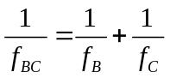

Near Object Method
- Place lens A in the lens holder on a single optical bench along with the screen and the object. As before, be sure that the lens is between the object and the screen. For various distances p>f_{A} of the object from the lens, move the screen until a sharp real image is formed on it. Make sure that the lens, the object and the screen are at the center of their respective holders. Measure the image distance q from the screen to the lens. Obtain 6-7 ordered pairs of object and image distances (p, q) for the lens. Record the values for p and q in Table 2.
- For each ordered pair above calculate, f_{A} , using the object-image formula 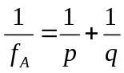 and record your results in Table 2. Then calculate the average for f_{A} along with its error, 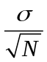 (this is the doubtful digit in the value of f_{A}). Record the average of f_{A} along with its error below Table 2 (watch significant figures).

Part 2: Two-Lens System
- Place the light source at 0.00 cm on the optical bench. Place lens C in a lens holder anywhere between the 30.00 cm and 40.00 cm mark on the optical bench. Place lens A in a lens holder a anywhere between the 50.00 cm and 60.00 cm mark on the optical bench move the screen until a sharp real image is formed on it. Measure and record (Table 3) the distance between the lenses, D, the distance from the object to lens C, and the distance from lens A to the image. Note the characteristics of the final image and record your observations in the Data section. You will need this information to draw a ray tracing for the system.

Part 3: Mirror-Lens System
- In this part of the experiment you will use a candle as the light source, and place it between a convex lens and a concave mirror (see setup below). The convex mirror is given by a known focal length (labeled on the lens), and distance between the lens and the mirror is about 30cm, the distance from the mirror to the candle is about 10cm. Are you going to observe only one image in this case? Place the screen on the other side of the lens and slowly move it toward the lens. Record your observations in Data section and you will need all these information to draw a ray tracing for the system.

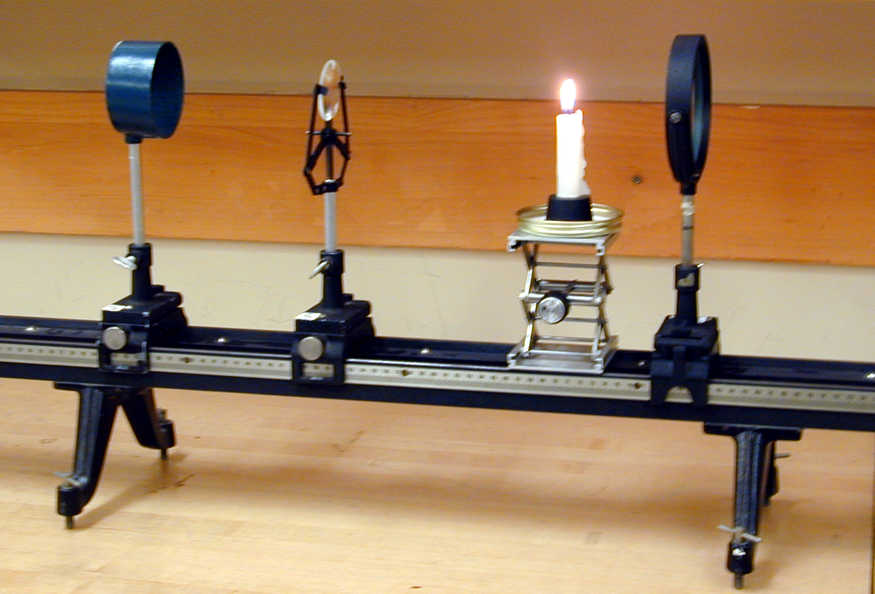

Analysis
Part 1: Focal Length Measurements

Near Object Method
- Plot 1/q vs.1/p and perform a linear fit to your data. Make sure that the origin of the graph is at its center. Also, make sure that maximum value on the x and y-axes is not less than 0.1cm⁻¹. Print a large copy of the graph Label the line “Lens A” Determine the focal length of lens A from your curve fit results.
- Using the results of Distant Object Method draw the line (use ink and a ruler) that is expected to represent Lens B on the graph from Step 1. Label the line “Lens B”. Repeat for Lens C (label the line “Lens C”), the concave mirror (label the line “Concave Mirror”). Finally, draw a line that represents a plane mirror (label the line “Plane Mirror”).
- Draw an accurate ray tracing for lens A using one of the ordered pairs (p, q). This must be done in ink and a ruler (no computer generated drawings or Xerox copies will be accepted). The lens, the object, the image, and the scale must be clearly labeled.

Part 2: Two-Lens System
- Draw an accurate ray tracing for this system. This must be done in ink and a ruler (no computer generated drawings or Xerox copies will be accepted). The lenses, the objects (real or virtual), the images (real or virtual), and the scale must be clearly labeled.

Part 3: Mirror-Lens System
- Draw an accurate ray tracing for this system. This must be done in ink and a ruler (no computer generated drawings or Xerox copies will be accepted). The lens and mirror, the objects (real or virtual), the images (real or virtual), and the scale must be clearly labeled.

Data

Part 1: Focal Length Measurements

Table 1: Distant Object Method
Element | Image Distance(cm) | Focal Length (cm)
A |  | f_{A} =
B |  | f_{B} =
Mirror |  | f_{M} =
C | f_{BC} = | f_{C} =

Table 2: Near Object Method for lens A
p (cm) | q (cm) | f_{A}(cm)

(f_{A})_{AVG}__________±_________

Part 2: Two-Lens System

Table 3: Two-Lens System
Object Distance (cm) | D (cm) | Image Distance (cm)
Observations:

Part 3: Mirror-Lens System

Observations:

Results
Part 1: Focal Length Measurements

Near Object Method

- Determine the value of f_{A} from the graph.

- What do the values in the second quadrant of the graph represent?

- Compare the value of f_{A} obtained from the distant object method to the value obtained from the near object method (below Table 2). Calculate the percent difference between the two values. How good is the distant object method?

- Compare the value of f_{A} obtained from the distant object method to the value obtained from the graph. Calculate the percent difference between the two values.

Part 2: Two-Lens System
- The ray tracing for this system can be used to explain correction to which of the following visual defects: myopia or hyperopia? Explain the nature of the visual defect this system can correct and how this system aids in rectifying it.

- Suppose an object is placed a distance p₁>f₁ to the left of a converging lens. Of course, the corresponding real image is observed a distance q₁ to the right of the lens. Now suppose a diverging lens of focal length f₂ is placed a distance d<q₁ to the right of the converging lens. Is the observed image real or virtual? Is it upright or inverted? Clearly state the basis for your answer.

Part 3: Mirror-Lens System
- Discuss the number of image(s) that would be observed if the object was a distance p>f_{M} from the mirror.

Ray Tracing, Part 1


Ray Tracing,Part 2

Ray Tracing, Part 3

