Experiment
7

The Magnetic Force

Introduction: A current-carrying wire in a magnetic field will experience a magnetic force, F_{B}. This fundamental interaction gives rise to important technologies such as electric motors and generators. In this experiment you will use PASCO’s Current Balance to investigate this force and its relationship to the current and the magnetic field. More specifically, you will experimentally look at:

Theory:

Write the vector equation for the magnetic force on a current-carrying wire placed in a B field in terms of I, L, B and q. Include a drawing to show the relationships between the vector quantities.

N
S

Show with a derivation how the above equation is a consequence of a more fundamental relationship involving a charge moving with a velocity in a magnetic field.

Procedure:

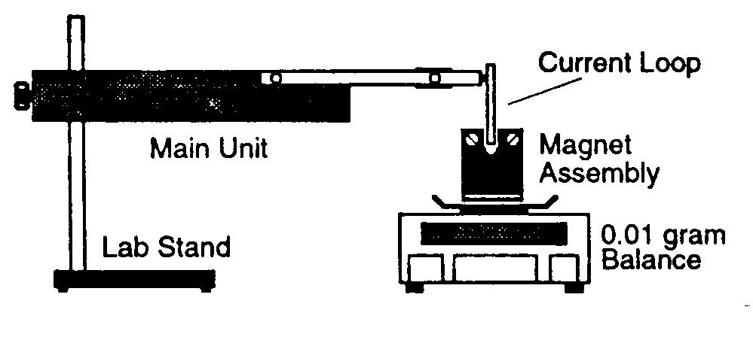
Part 1: Force vs. Current
SF-?? or SF-?? (to be determined by instructor)

Figure 1.1

Power Supply
Ammeter
0-5 (max)
Variable Resistor
Base Unit

Figure 1.2

Mount the Main Unit on a lab stand. Select a Current Loop SF-?? (single-sided) and plug it into the ends of the arm of the Main Unit, with the foil extending down.

Place the Magnet Assembly on a balance with at least 0.01 gram sensitivity. Position the lab stand so the horizontal portion of the conductive foil on the Current Loop passes through the pole region of the magnets (See Figure 1.1). The Current Loop shouldn’t touch the magnets.

Connect the power supply, ammeter, and resistor as shown in Figure 1.2.

With no current flowing, press the TARE button, bring the reading to 0.00 grams. This subtracts the weight of the Magnet Assembly from ensuing weight measurements, so only the force caused by the current will be measured.

Procedure continued:

Now turn on the power supply and set the knob on “1”. If the reading is negative, reverse the leads on power supply (What does the negative reading mean?). Record the current value and mass value in Table 1.1.

Increase the settings over the range of the power supply (up to 12) and take the ordered pairs of data. Record the data in Table 1.1.

Measure the length of the conductive foil on the Current Loop (Watch out, the effective length may be somewhat shorter than the maximum length of the foil). Record this value under Table 1.1.

Replace Current Loop with new unit SF-?? (double-sided). Repeat steps 1 through 7 and record the data in Table 1.2. Be sure that the total effective length is twice your measured length.

Note: The current should not exceed 5 amps during the experiment.

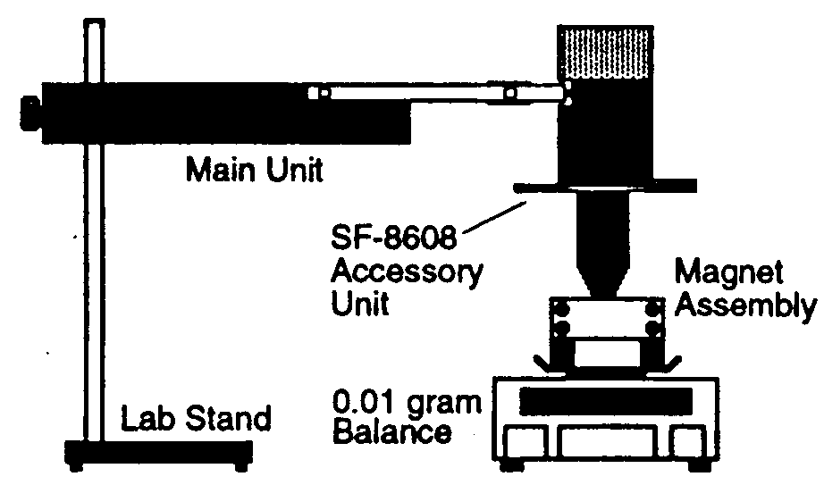
Part 2: Force vs. Angle

Figure 2

Replace the Current Loop SF-?? with the SF-8608 Accessory Unit including the Magnet Assembly. Reposition the Main Unit to accommodate the new Accessory Unit. Set the dial on the Accessory Unit to 0º, and align the Magnet Assembly so that the magnetic field is approximately parallel with the wires of the coil. This means that the scale reading must be zero when the angle is 0º.

With the power supply turned off, TARE the balance. Set the power supply to setting “6”, turn it on and check to see that the current is around 2.00 amps. If not, adjust the variable resistor to achieve this desired current.

Measure and record the angle and corresponding mass, and record this data in Table 2.

Increase the angle in 5º increments up to 90º, and then in –5º increments to –90º. At each angle, take the data and record the data in Table 2.

Data:

Table 1.1

P.S. Setting | I (A) | Mass (g) | F (N)

0

1

2

3

4

5

6

7

8

9

10

11

12

Effective length of foil, L = ________________

Data continued:

Table 1.2

P.S. Setting | I (A) | Mass (g) | F (N)

0

1

2

3

4

5

6

7

8

9

10

11

12

One side, effective length of foil = ________________

Total effective Length of foil, L = ________________

Table 2

θ | Mass (g) | F (N) | θ | Mass (g) | F (N)
0.0 |  |  | 0.0
5.0 |  |  | -5.0
10.0 |  |  | -10.0
15.0 |  |  | -15.0
20.0 |  |  | -20.0
25.0 |  |  | -25.0
30.0 |  |  | -30.0
35.0 |  |  | -35.0
40.0 |  |  | -40.0
45.0 |  |  | -45.0
50.0 |  |  | -50.0
55.0 |  |  | -55.0
60.0 |  |  | -60.0
65.0 |  |  | -65.0
70.0 |  |  | -70.0
75.0 |  |  | -75.0
80.0 |  |  | -80.0
85.0 |  |  | -85.0
90.0 |  |  | -90.0

Analysis and Result
Answer questions in complete sentences!

Part 1
- From the data you recorded in Table 1.1 and Table 1.2, plot F vs. I for Current Loops SF-?? (single-sided) and SF-?? (double-sided) respectively. Copy and paste your graphs below.

- Calculate the strength of the magnetic field B using the slopes from your graphs and the equation you gave in your Theory for each case. Calculate the percent difference of the two values. Don’t forget to report your results to the correct number of significant figures based on the standard deviation of the curve fit. Show one of your calculations below.

Results

Unit | Slope (N/A) | Calculated B (Tesla)
SF-__
SF-__

Part 2
- From the data you recorded in Table 2, plot F vs. sin θ for the SF-8608 Accessory Unit. If your graph does not look linear, then you did not follow the directions correctly. You’ll probably have to retake the data. Copy and paste your graph below
- What is the expected value for the slope of your graph?

- Compare the slope of your graph to the expected value (e.g. calculate percent difference).

- Comment on your results (e.g. do your results agree with the expected value? Why? Of Why not?)

