Experiment
2

Speed of Sound

Introduction: In this four part experiment, some interesting and important behaviors of waves will be studied and used to measure the speed of sound in three different media: air, helium and brass. Before beginning, you should review and/or be familiar with most of the information covered in Chapters 15, 16 and 17 of your text. Here is an outline of this study of waves:

Part 1: Investigate the speed of waves on a string and compare the value obtained from the tension and linear density to the value derived from the frequency and wavelength.
Part 2: Measure the speed of sound in air and helium from time-of-flight data obtained electronically.
Part 3: Measure the speed of sound in air from measurements made on a standing wave in an air column with one end open. An audible sound source will generate the standing wave.
Part 4: Measure the speed of sound in brass using a Kundt’s Tube.

Theory: To help you prepare, explain each of the following in the space provided.

1. Characteristics and properties of transverse and longitudinal waves. Draw a representation of each to add clarification.

2. The relationship between the frequency and speed of a wave and the corresponding wavelength. Be sure to define the common symbols used.

3. The relationship for the speed of a wave on a string as a function of the string tension and linear density.

Theory:

4. The Superposition Principle.

- The requirements for a standing wave on a string fixed at both ends. Show a drawing to add clarification.

6. The requirements for a standing wave in an air column open at one end. Include a drawing for clarification. Are the nodes pressure or displacement nodes?

7. The speed of sound in a gas as a function of the properties of the gas (which?).

8. The speed of sound in a solid as a function of the properties of the solid (which?).
Procedure:

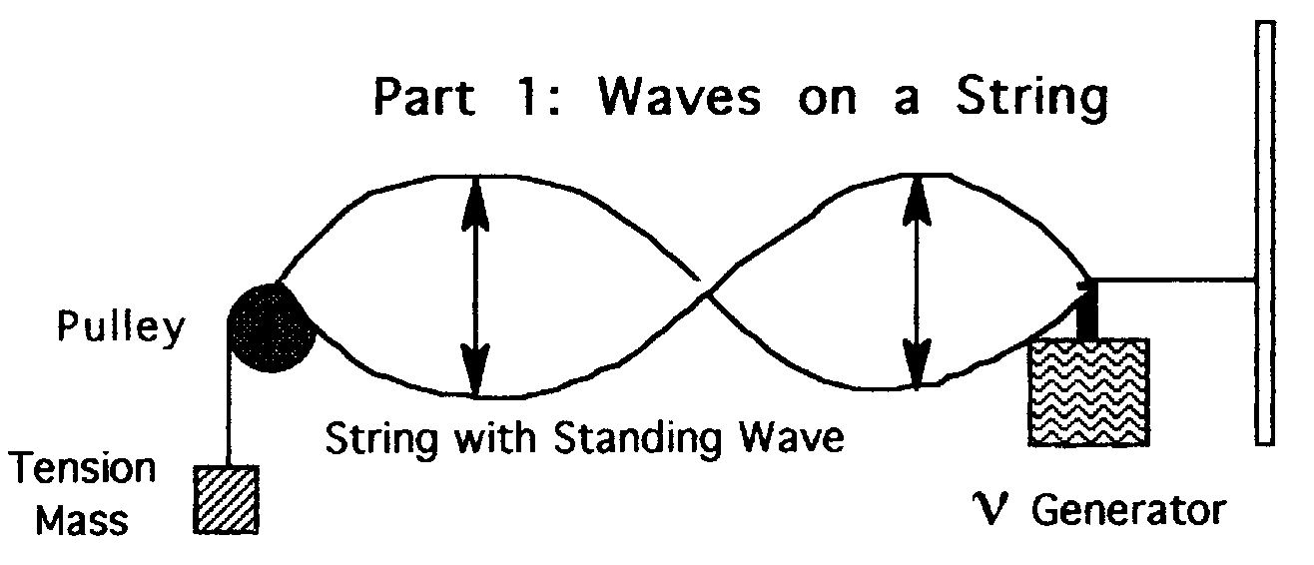

- Check the system to be sure that it is set up as shown above.
- Adjust the generator frequency to its lowest setting, then turn on the power.
- Slowly increase the frequency until a standing wave results. This should be the fundamental (n=1). Adjust the frequency carefully to give the maximum amplitude and record this frequency, along with the number of wavelengths observed in the standing wave pattern, in the data section for part 1. Minimize the length of time that the generator is on by doing the above quickly (but carefully), and move on to step 4.
- Increase the frequency again until the second harmonic results (n=2), adjust for maximum amplitude and record the frequency and number of wavelengths.
- Repeat step 4 for the third harmonic, then turn the generator power off.
- Carefully measure and record the standing wave string length (l, which is the distance from the generator to the pulley), and the tension mass (M_{T}).
- Measure/record the length of a separate piece of string (L) and its mass (M_{S}).

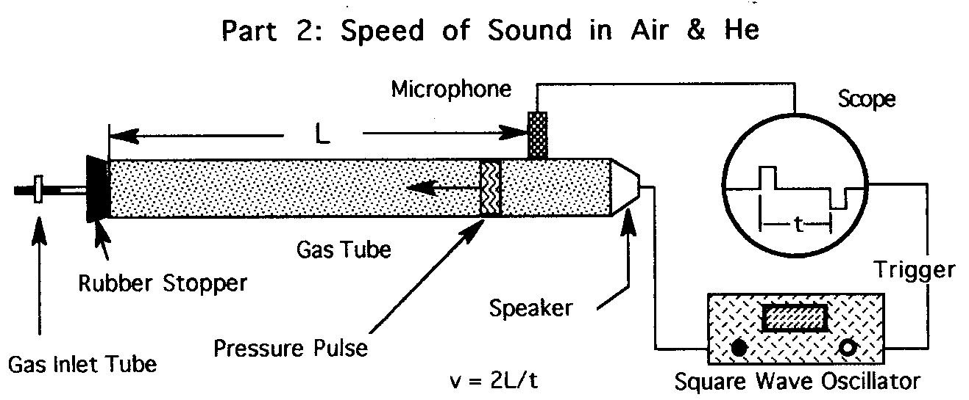
- Locate the power button on the front of the oscilloscope and push it in to turn on the “scope”. If you do not get a free-running trace and do not know how to use this instrument, see your instructor before continuing
- Now turn on the square wave generator. You should see a pattern like the one show on the scope above. If not, again see your instructor for help.
- Carefully measure the number of major divisions from the graticule of the scope corresponding to the time (t) shown in the diagram (watch your sig. figs) and record in the data section for part 2. Also record the time base setting (#s/div.).
- Carefully measure L using a two meter stick equipped with caliper jaws. L is defined on the gas tube with lines drawn at both ends.
- Turn off the generator, locate the plastic beach ball fitted with surgical tubing and hose clamp, and obtain H_{e} gas from your instructor.
- Connect the end of the tubing to the gas inlet tube, turn on the generator, check to see that you have the same signal as before on the scope, open the clamp on the tubing, and slowly squeeze the beach ball to force the H_{e} into the gas tube. What happens to the signal on the scope? Now repeat step 3.
- Finally, measure and record the ambient temperature.
- When finished, be sure to turn the generator and scope off.

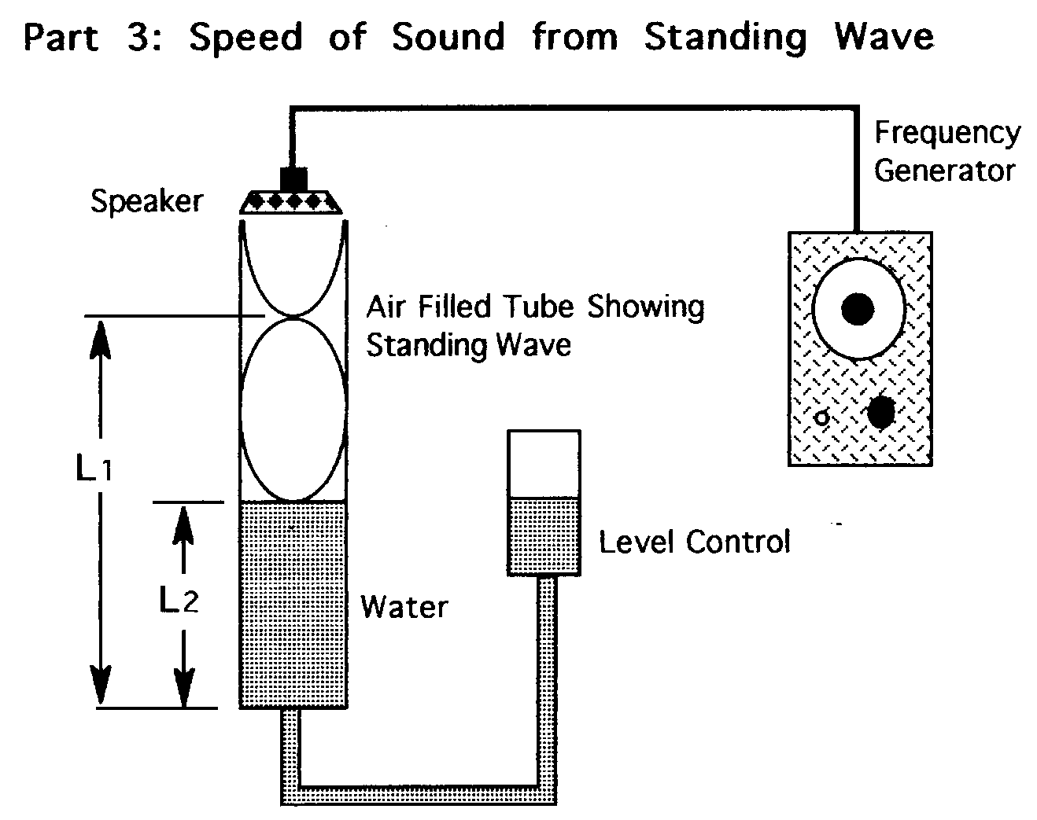
- Unclamp the level control and raise it up until the water level is close to the top, then reclamp.
- Locate the amplitude (intensity) knob on the generator and turn it down as far as it will go (FCCW).
- Turn on the generator and adjust the frequency to 426, then slowly turn up the amplitude until the sound is audible but the intensity is low.
- Locate the 426.6 Hz tuning fork and striker. Fine tune the generator by striking the fork while the generator is on, listen for beats, and adjust the frequency control until the beats just disappear (review pages 354 of your text on “beats”).
- Now slowly lower the water level (level control) and listen for an increase in the sound intensity. Carefully adjust the water level to maximum sound intensity, and read and record L1 as shown in the diagram.
- Repeat step 5 for L2.
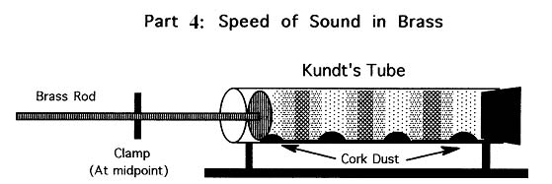
- Measure and record room temperature.
- You will probably find the Kundt’s Tube as shown above with the cork dust in a distinct pile-type pattern (a group has just finished). The dust must be redistributed evenly along the bottom of the tube. Carefully rotate and tap it until this result is achieved. Be careful not to touch the brass rod with your fingers during this operation or at any time during the experiment. Furthermore, the brass rod must be clamped at it’s midpoint. Why?
- Obtain the rosin cloth and wrap it around the brass rod just to the left of the clamp (viewed as shown in the diagram) with the rosin side against the brass.
- Grip the cloth firmly with one hand as you hold the wooden base with the other, and pull the cloth toward you. You should hear a high pitched sound of medium intensity as you pull. If not, try gripping the cloth with different degrees of firmness, adding some rosin to the cloth, and/or cleaning the brass rod with a small amount of ethanol on a tissue
- After a few successful strokes, you will notice the cork dust has formed the pile-type pattern shown. Continue stroking the rod until no discernible change in the pattern can be seen (usually no more than ten strokes).
- Observe the pattern carefully and notice that it repeats itself down the length of the tube. Pick out a distinctive reference point in the pattern closest to one end of the tube, then find this same reference point in the pattern at the other end of the tube. Mark these two points with a felt tip marker on the top of the glass tube and measure and record the distance carefully with a meter stick. Also count and record the number of wavelengths in this distance.
- Now measure and record the distance from the left end of the brass rod (viewed as shown in the diagram) to the point of contact of the clamp with the brass rod.
- Finally, measure and record room temperature.

Can You Answer These?
1. Why does the brass respond to the rosin cloth by producing sound?

2. What is the significance of the clamp?

3. Why does the brass rod have to be clamped at its midpoint?

4. Why does the cork dust pile up?

5. How do the measurements you are asked to make lead to the speed of sound in brass?
Data:
Part 1

 | n | Frequency (Hz) |  |  | # Wavelengths
 | 1 | ___________________ |  |  | ___________________
 | 2 | ___________________ |  |  | ___________________
 | 3 | ___________________ |  |  | ___________________
l = _____________ |  |  | L = _____________ | M_{s} = _____________ |  | M_{T} = _____________

Part 2

 |  | Air: |  | # divisions = _____________ |  | #s/div. = _____________
 |  | H_{e}: |  | # divisions = _____________ |  | #s/div. = _____________
 |  |  | L = _______________ |  | T = _______________

Part 3

 | Frequency = _______________ | L₁ = _______________
 | Temperature = _______________ | L₂ = _______________

Part 4

Length of Cork Dust Pattern = ________________________________________

Number of Wavelengths Measured = ___________________________________

Length of Brass Rod (from clamp to end) = ______________________________

Room Temperature = _______________________________________________

Analysis:

Part 1

- For each of the standing waves generated, calculate the wavelength.
- From these wavelengths and their frequencies and the equation you explained in Theory #2, calculate the speeds of the three traveling waves.
- Average these three speeds and record the result in “Results, Part 1”.
- Calculate the linear density of the string from L and M_{s}.
- Also calculate the tension in the string from M_{T}.
- Using the equation you explained in Theory #3, calculate the speed of the wave and record in the result section.
- Finally, using the average speed calculated in #3 as the accepted value, calculate and report a % error for the wave speed calculated in #6.

Part 2

- From the # divisions and the #s/div., calculate the time of flight for the sound wave in air.
- Using this time and the length of the tube (L), calculate and report the speed of sound in air. Remember, the distance traveled is 2L.
- For comparison, calculate and report the speed of sound in air using the formula 331.5 + 0.607T m/s (where T is the air temperature in degrees Celsius), then calculate and report a % error for the value determined in #2.
- Repeat steps 1 and 2 for H_{e}. Also, look up and report a reference value for the speed of sound in H_{e}.

Part 3

- From L₁ and L₂ calculate the wavelength of sound in air.
- Using the formula that you explained in theory #2 together with the wavelength determined in #1, calculate and report the speed of sound in air.
- For comparison, repeat step 3 from Analysis Part 2.

Part 4

- Begin by determining the wavelength of the sound in the air tube (divide the length of the cork dust pattern by the number of wavelengths measured in that pattern).
- From the measured room temperature and the formula for the speed of sound in air given in step 3, Part 2 of this analysis, calculate the speed of the wave.
- Now calculate the frequency of the sound using the formula you explained in Theory #2 and the wavelength and speed calculated in #1 and #2.
- In order to calculate the speed of sound in brass, you need both the frequency and the wavelength of the sound in brass. The frequency will be the same as in the air just calculated (step #3). The wavelength comes from your measurement of the brass rod from the clamp to the end closest to you as you rubbed the rod. This distance is equal to ¼ of a wavelength. Why? Be sure to report your result for the speed of sound in brass. See if you can find a value in the reference library, or calculate one from Young’s modulus and the density of brass and report a % error.

Results:

Part 1

 | Speed of String Wave (standing wave): | __________________________
 | Speed of String Wave (properties): | __________________________
 | % Error: | __________________________

Part 2

 |  | H_{e} | Air
 | Speed of Sound: | __________________ | __________________
 | Speed of Sound, Accepted: | __________________ | __________________
 | % Error: | __________________ | __________________

Part 3

 | Speed of Sound in Air: | __________________________
 | Speed of Sound, Accepted: | __________________________
 | % Error: | __________________________

Part 4

 | Speed of Sound in Brass: | __________________________
 | Speed of Sound, Accepted: | __________________________
 | % Error: | __________________________

