## Experiment

**14**

Diffraction and Interference

**Purpose**

1. Examine the diffraction pattern formed by laser light passing through a single slit and verify that the positions of the minima in the diffraction pattern match the positions predicted by theory.
2. Examine the diffraction and interference patterns formed by laser light passing through two slits and verify that the positions of the maxima in the interference pattern match the positions predicted by theory.

**Theory**

1. When diffraction of light occurs as it passes through a slit, the angle to the minima in the diffraction pattern is given by

* m = 1, 2, 3,…)*

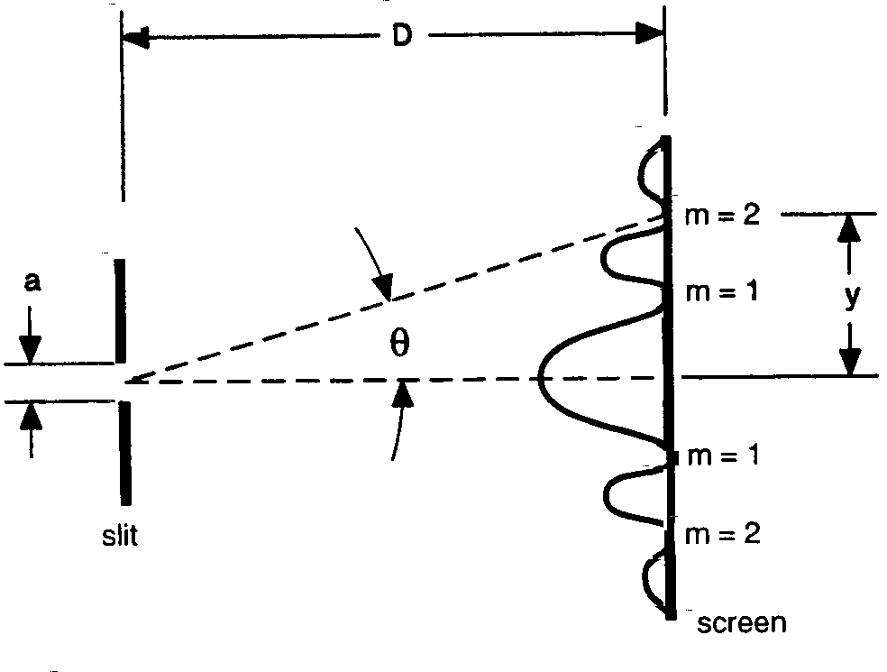

where *a* is the slit width, ** is the angle from the center of the pattern to the *mth* minimum, * *is the wavelength of the light, and *m* is the order (1for the first minimum, 2 for the second minimum, …counting from the center out). See Figure 1.

Since the angles are usually small, it can be assumed that

**

**

From trigonometry,

Figure 1: Single Slit Diffraction Pattern

**

where *y* is the distance on the screen from the center of the pattern to the *mth* minimum and *D* is the distance from the slit to the screen as shown in Figure 1. The diffraction equation can thus be solved for the slit width:

 *(m = 1, 2, 3,…)*

1. When light passes through two slits, the two light rays emerging from the slits interfere with each other and produce interference fringes. The angle to the maxima (bright fringes) in the interference pattern is given by

* m = 0, 1, 2, 3,…)*

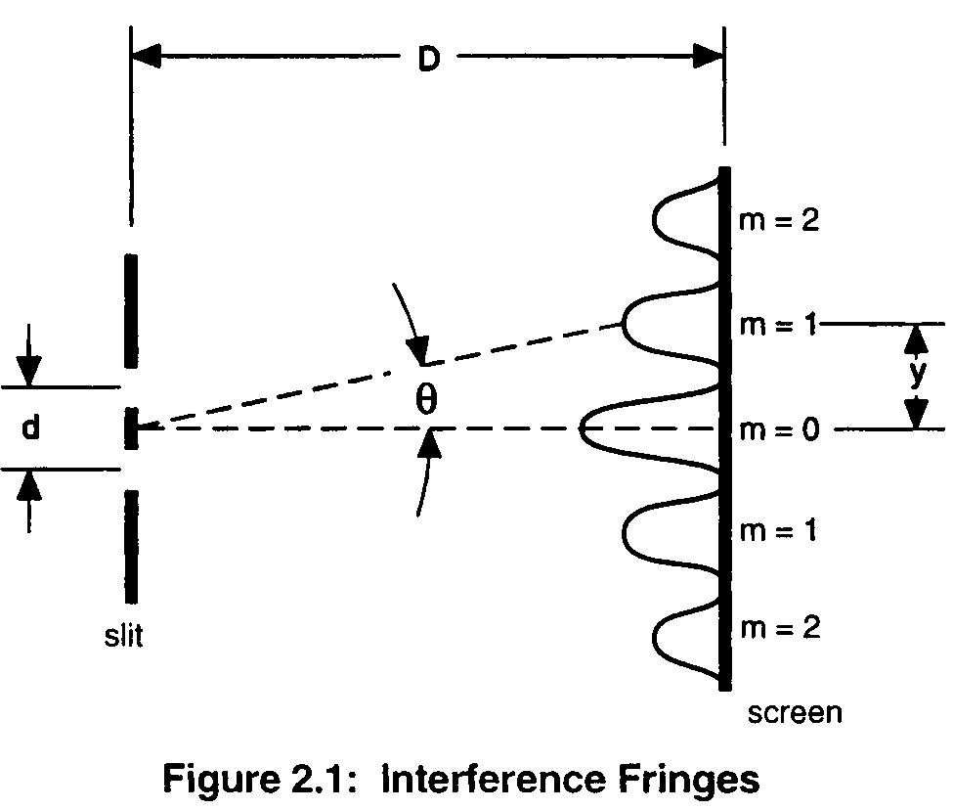

where *d* is the slit separation, ** is the angle from the center of the pattern to the *mth* maximum, * *is the wavelength of the light, and *m* is the order (0 for the central maximum, 1 for the first side maximum, 2 for the second side maximum, ...counting from the center out). See Figure 2.

Since the angles are usually small, it can be assumed that



From trigonometry,



**Figure 2: Interference Fringes**

where *y* is the distance on the screen from the center of the pattern to the *mth* maximum and *D* is the distance from the slits to the screen as shown in Figure 2. The interference equation can thus be solved for the slit separation:

 *(m = 0, 1, 2, 3,…)*

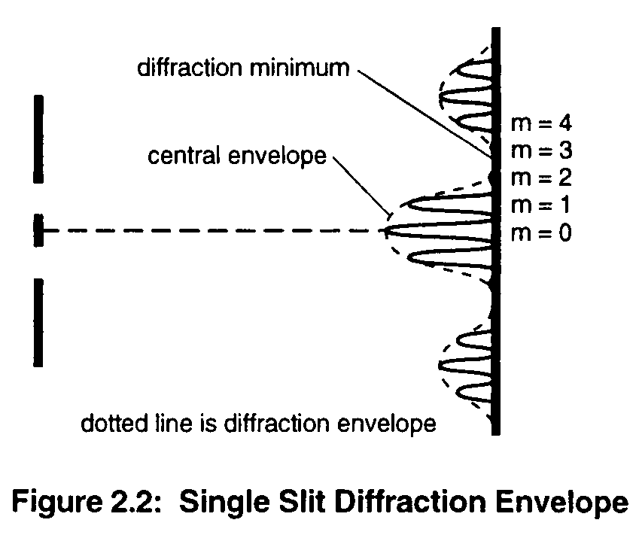

While the interference fringes are created by the interference of the light coming from the two slits, there is also a diffraction effect occurring at each slit due to Single Slit diffraction. This causes the envelope as seen in Figure 3.

**Figure 3: Single Slit Diffraction Envelope**

**EQUIPMENT REQUIRED**

* PASCO 750 Computer Interface
* Light Sensor
* Rotary Motion Sensor (RMS)
* Single Slit Disk
* Double Slit Disk
* Diode Laser
* Linear Translator
* Aperture Bracket
* Optics Bench

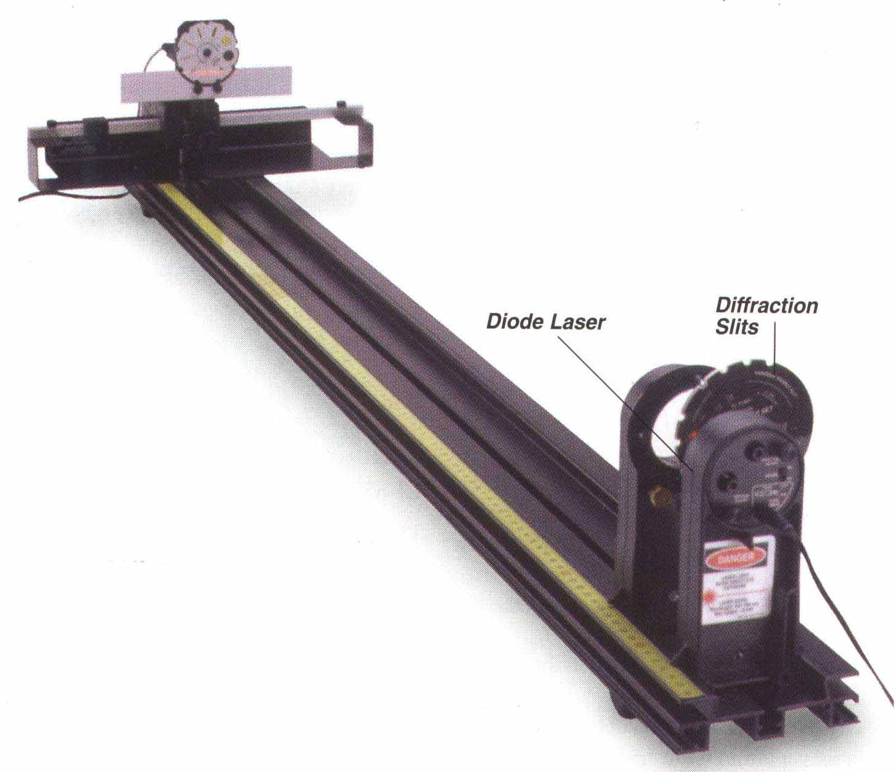

**Procedure**

1. Open *DataStudio2A* folder on the desktop of the computer. Select *diffraction.ds*.
2. Set up the laser at one end of the optics bench and place the Single Slit Disk in its holder about 3 cm in front of the laser. See Figure 4.
3. Select the 0.08 mm slit by rotating the slit disk until the 0.08 mm slit is centered in the slit holder. Adjust the position of the laser beam from left-to-right and up-to-down until the beam is centered on the slit.
4. Set gain to 1 on the Light Sensor, and adjust the height of the Aperture Bracket so the Light Sensor probe is at the same height as the diffraction pattern created by the single slit.
5. Move the Rotary Motion Sensor to the far end of its track. Click the **Start** to begin collecting data.
6. Slowly and smoothly move the Rotary Motion Sensor so that the maxima of the diffraction pattern move across the probe.
7. When the entire diffraction pattern has been measured, click the **STOP** to stop collecting data.
8. Click the Graph to make it active. Click the “Scale to fit**”** button ( scaletofit ) to rescale the Graph to fit the data. Print the Graph as Graph 1.
9. Click the “Zoom Select” button ( ZoomSelect ) to magnify the central maximum. Then click the “Smart Tool**”** button ( Smart Tool ) to determine the distance between the first orders (m = 1) and record this distance in Table 1. Also measure the distance between the second orders (m = 2) and record in Table 1.
10. Determine the distance from the slit to the Light Sensor Probe. Record it in Table 1.
11. Change the slit width to 0.16 mm and 0.04 mm and observe differences.
12. Replace the Single Slit Disk with the Multiple Slit Disk.
13. Select the double slit with 0.04 mm slit width and 0.25 mm slit separation. Repeat the steps 5 to 10. Print the graph as graph 2 and record the data in Table 2. (You may need to magnify the central single-slit maximum by clicking the “Zoom Select” button)
14. Change to a new double slit with the same slit width (0.04 mm) but different slit separation (0.50 mm) and observe differences.
15. Change to another double slit with a slit width of 0.08 mm and the original slit separation (0.25 mm) and observe differences.

16. After recording data turn off the laser power switch.

**Analysis**

**Part 1**

1. Divide the distances between side orders by two to get the distances from the center of the pattern to the first and second order minima. Record these values of y in Table 1.
2. Using the average wavelength of the laser (670 nm for the Diode Laser), calculate the slit width twice, once using first order and once using second order. Record the results in Table 1.
3. Calculate the percent error between the experimental slit widths and 0.08 mm. Record in Table 1.

### Table 1: Data and Results for the 0.08 mm Single Slit

Slit-to-Light Sensor Probe distance (D) = ____________________­­

|  |  |  |
| --- | --- | --- |
|  | First Order (m = 1) | Second Order (m = 2) |
| Distance between  Side orders |  |  |
| Distance from center  To side (y) |  |  |
| Calculated slit width |  |  |
| % Error |  |  |

**Part 2**

1. Divide the distances between side orders by two to get the distances from the center of the pattern to the first and second order maxima. Record these values of y in Table 2.
2. Using the average wavelength of the laser (670 nm for the Diode Laser), calculate the slit separation twice, once using first order and once using second order. Record the results in Table 2.
3. Calculate the percent error between the experimental slit separation and 0.25 mm. Record in Table 2.

**Table 2: Data and Results for the 0.04 mm/0.25 mm Double Slit**

Slit-to-Light Sensor Probe distance (D) = ____________________

|  |  |  |
| --- | --- | --- |
|  | First Order (m = 1) | Second Order (m = 2) |
| Distance between  Side orders |  |  |
| Distance from center  To side (y) |  |  |
| Calculated slit  separation |  |  |
| % Error |  |  |

**Questions**

1. For single slit interference pattern, does the distance between minima increase or decrease when the slit width is increased? ­­____________
2. For double slit interference pattern,
3. Does the distance between maxima increase, decrease, or stay the same when the slit separation is increased? ____________
4. Does the distance between maxima increase, decrease, or stay the same when the slit width is increased? _____________
5. Does the distance to the first minima of the diffraction envelope increase, decrease, of stay the same when the slit separation is increased? ________
6. Does the distance to the first minima of the diffraction envelope increase, decrease, or stay the same when the slit width is increased? ____________
7. What are the similarities and differences between the single slit pattern and the double slit pattern?