PHYSICS 4A EXAM 3
October 25, 2002
Name:____________________

Rules for Exam:
- Only Scientific Calculators are allowed!
- Show your work on non-multiple choice problems. NO WORK=NO CREDIT.
- Include units with each answer. One point deduction per infraction.
- Round off to 2 decimal places and circle your final answers.
- Circle your final answers.
Good Luck!

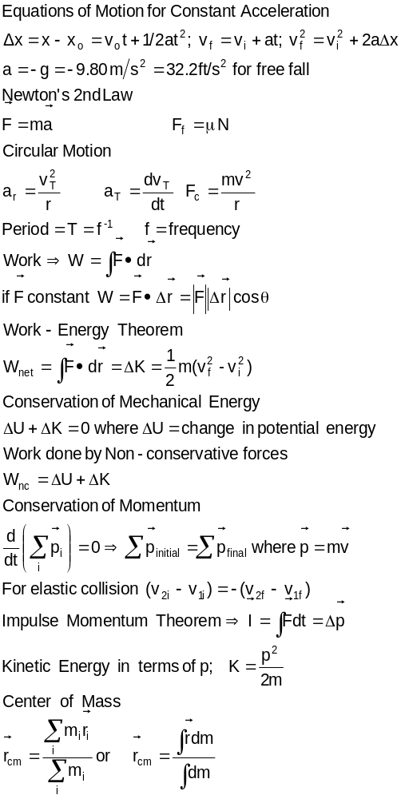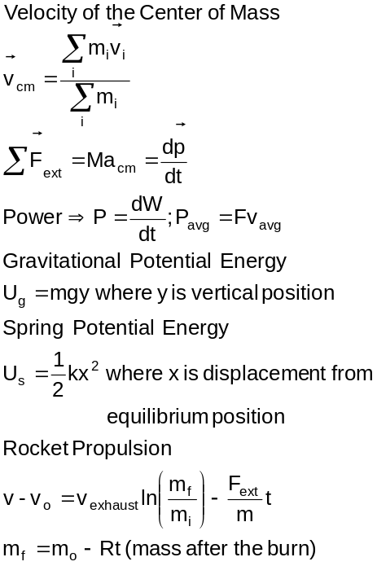

Scores

Part 1 (20 pts)
Prob 1 (15 pts)

Prob 2 (15 pts)
Prob 3 (20 pts)
Prob 4 (15 pts)
TOTAL (85 max)

% (out of 85)

Multiple choice and short answer questions (4 points each)

- You push a block up a frictionless hill at constant speed. The work that you do in pushing the block up the hill is equal to
- ΔU
- −ΔU
- 0
- none of the above

- The power you must deliver to the block in question 1
- increases
- decreases
- remains constant
as the distance traveled up the hill increases.

- Two pucks of mass m₁ and m₂ are lying on a frictionless table and connected by a spring of force constant k. A horizontal force F₁ is exerted only on m₁ along the spring away from m₂. What is the magnitude of the acceleration of the center of mass of the system?
- F₁/m₁
- F₁/(m₁+m₂)
- (F₁ +kΔx)/(m₁m₂), where Δx is the amount the spring is stretched.
- (m₁+m₂)F₁/(m₁m₂)

- A force of F is applied to a particle as it moves through a displacement S. If F=(3i-4j+2k)N, and S=(-10i+9j-5k)m, what is the work done by F?
- -95J
- -76J
- –5J
- +15J
- +95J

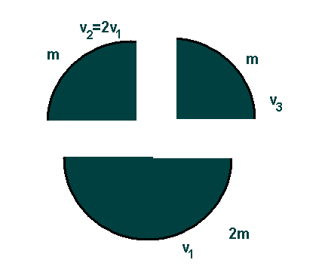
- The figure shows the behavior of a projectile just after it has broken up into 3 pieces. What was the speed of the projectile the instant before it broke up?
- v₃
- v₃/3
- v₃/4
- 4v₃
- (v₁+v₂+v₃)/4

A,C,B,B,C

PROBLEMS
- A spring that does not conform to Hooke’s Law has a force whose magnitude is given by F=(6x² +2x)N with its direction opposite to the displacement of the spring. One end of the spring is attached to a support and a 2kg mass is suspended from the other end. The mass is raised so that the spring is un-stretched and released from rest. How fast (in m/s) is the mass traveling after it has fallen 1.00m? (15 points).

V=4.07m/s

- A toy car of mass m is given an initial velocity v toward the loop of radius r=0.25m. Calculate the minimum value v such that it barely makes it around the loop (15 points).

r
Toy car

V=3.5m/s

- A 2.0 kg block is given an initial velocity of 5.0m/s at point A. The block goes up the hill a distance d and then heads back down. If the coefficient of static and kinetic friction between the block and the hill are 0.4 and 0.3, respectively, how fast is the block traveling when it returns to point A (20 points)?
53º
A
v_{i}=5.0m/s

V=3.97m/s

- A ball of mass 0.250 kg has a velocity of 4.00j m/s; a ball of mass 0.500kg has a velocity of -0.50j m/s. They meet in a head-on elastic collision. Find their velocities after the collision and the velocity of the center of mass after the collision (15 points).

V1=-2.00m/sj
V2=2.50m/sj

